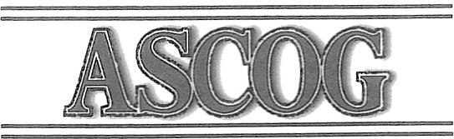
ASSOCIATION Of SOUTH CENTRAL
OKLAHOMA GOVERNMENTS

TO: Board of Trustees

FROM: DATE:

Perry Brinegar, Executive Director
August 28, 2025

SUBJECT: ASCOG Board of Trustees Meeting (ANNUAL BANQUET)

The ASCOG Trustees will meet on Thursday, September 18, 2025, at 6:30 p.m. The meeting will be at the Stephens County Fair building, 2002 S. 13th, Duncan, Ok.

Agenda, readahead, and issue information papers on agenda items requiring board action are attached should there be any.

We look forward to seeing you at the September Board meeting (Banquet)
PLEASE RSVP TO Joyce @580-736-7969 or 580-574-2132
Meat, Teas, Water, Breads, will be provided, a covered dish is requested.
If you cannot attend, please contact me at 580-736-7019 or
brin_admin@ascog.org.

802 W. Main, P.O. Box 1647 Duncan, OK 73534-1647

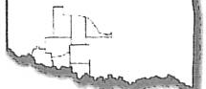
Phone: (580) 252-0595 or l-800-658-1466 Fax: (580) 252-0325 • www.ascog.org

AGENDA
ASCOG BOARD OF TRUSTEES MEETING
Thursday September 18, 2025, 6:30 P.M.
Stephens County Fair Building
2002 S. 13th, DUNCAN, OK.

- Call to Order Jesse Cross, President.

- Report on Budget-Robert Crews, Treasurer, Robert Denard, Director RM

- Review, Consider, act on Minutes of ASCOG Board Meeting June 19, 2025

- Adjournment

